Task 3.1: Implementing Dynamic Features with JavaScript
Overview
In this Touchstone task, you will begin adding simple dynamic behavior to your webpages using JavaScript. You will use click events to display alert messages when users interact with different buttons and form elements. These features introduce the basic JavaScript skills that you will continue developing in later Touchstone tasks.
You will complete the following:
- Add a JavaScript alert for the Subscribe button in the footer of every webpage.
- On the Gallery page, add alert messages to the Add to Cart, Clear Cart, and Process Order buttons. These buttons act as placeholders for features you will build later. For this task, each button only needs to display a simple alert when clicked.
- On the About Us/Contact page, add a JavaScript alert to the Submit button on the contact form.
Each alert should activate through a click event and display one of the following messages:
• “Thank you for subscribing.”
• “Item added to the cart.”
• “Cart cleared.”
• “Thank you for your order.”
• “Thank you for your message.”
Finally, document any issues or errors you encountered while developing your code. Remember that any component colors, font colors, and typography styling should be consistent with your choices in Task 1 and should be appropriate according to the client description provided in the Client Scenario and Criteria.

Instructions
Provide your responses in the following table.

Rendered Subscribe Feature Alert Window Screenshot
Hint: Provide a screenshot showing the alert message that appears when the user clicks the Subscribe button.

I added a click event listener to the Subscribe button in the footer of every webpage by selecting the subscribe form using document.getElementById and attaching a submit event listener. When the user clicks Subscribe, the event.preventDefault() method prevents the form from actually submitting, and the alert("Thank you for subscribing.") function displays the confirmation message. The same script is included at the bottom of the body section on all four HTML pages (index.html, gallery.html, about.html, and events.html), ensuring consistent behavior across the entire website.
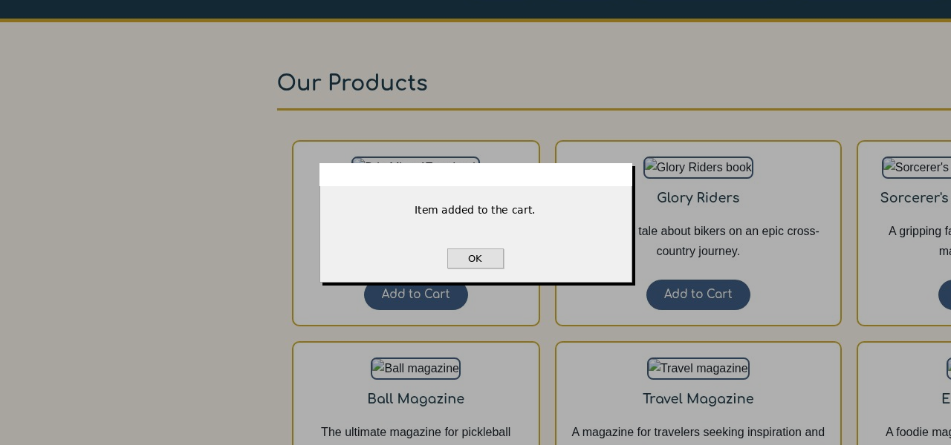

Subscribe Feature Alert Window Analysis
Hint: Briefly describe how you implemented the Subscribe button alert.
I selected all "Add to Cart" buttons on the Gallery page using document.querySelectorAll('.add-to-cart-btn'), which returns a NodeList of all nine buttons (one for each product). I then used the forEach method to iterate through each button and attach a click event listener. When any "Add to Cart" button is clicked, the alert("Item added to the cart.") message displays. No shopping cart logic, item tracking, or conditional checks were implemented for this task, as the buttons serve as placeholders for future cart functionality.
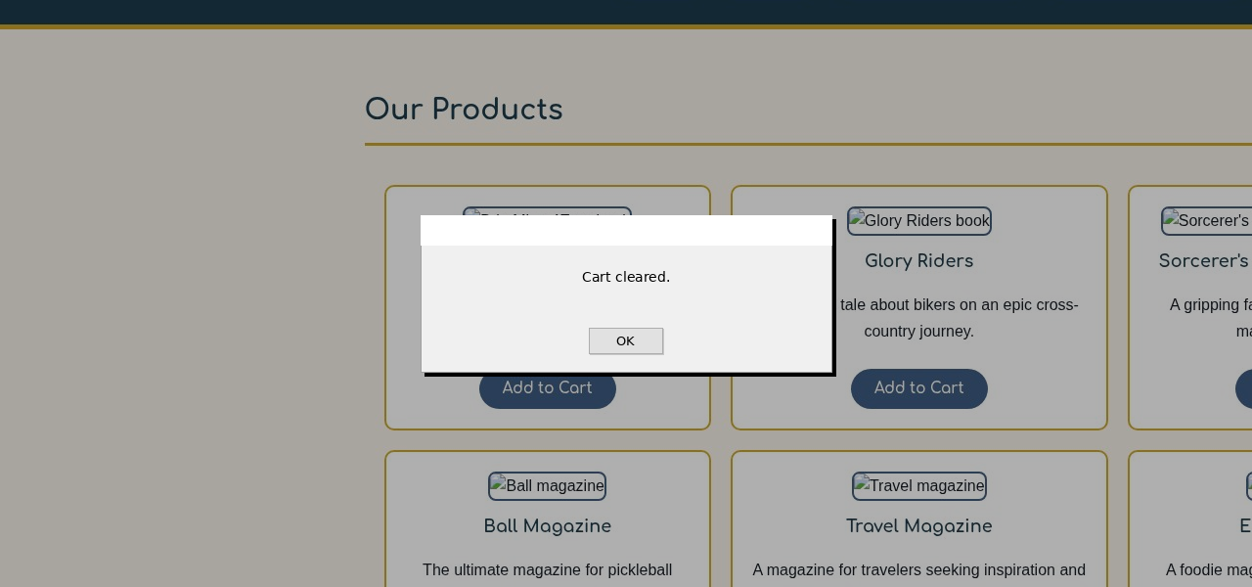
The Clear Cart button uses document.getElementById('clear-cart-btn') to select the button element by its unique ID. A click event listener is attached that calls alert("Cart cleared.") whenever the button is pressed. This button is a placeholder for future cart functionality that will be added in later lessons. For this task, it only needs to display the confirmation alert message.

Rendered Add to Cart Button Alert Screenshot (Gallery Page)
Hint: Provide a screenshot showing the alert message that appears when clicking any “Add to Cart” button on the Gallery page.
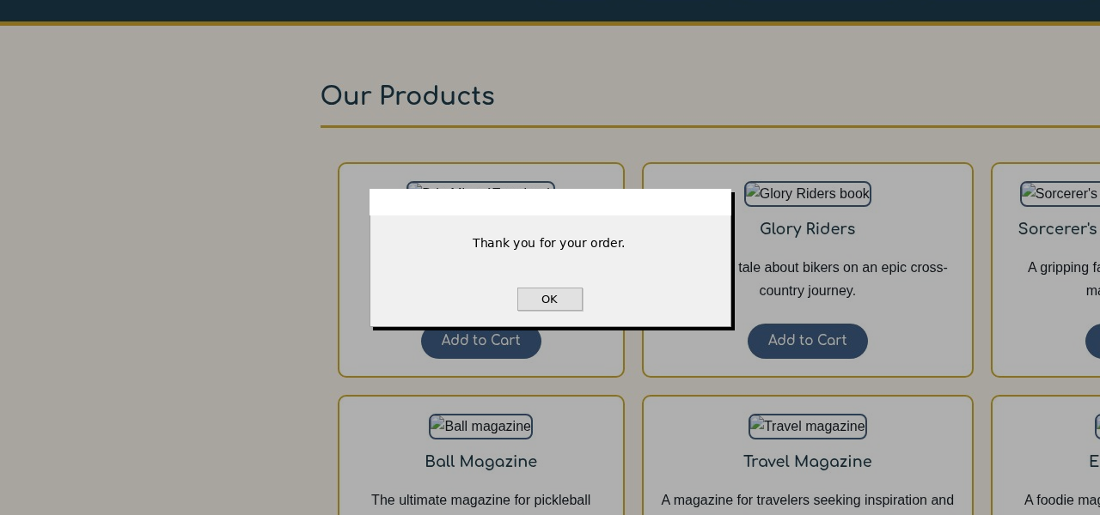
I added an event listener to the Process Order button using document.getElementById('process-order-btn'). When clicked, the event handler displays the alert message "Thank you for your order." This button serves as a placeholder for the future order processing functionality and confirms that the click event is properly wired to the button element.
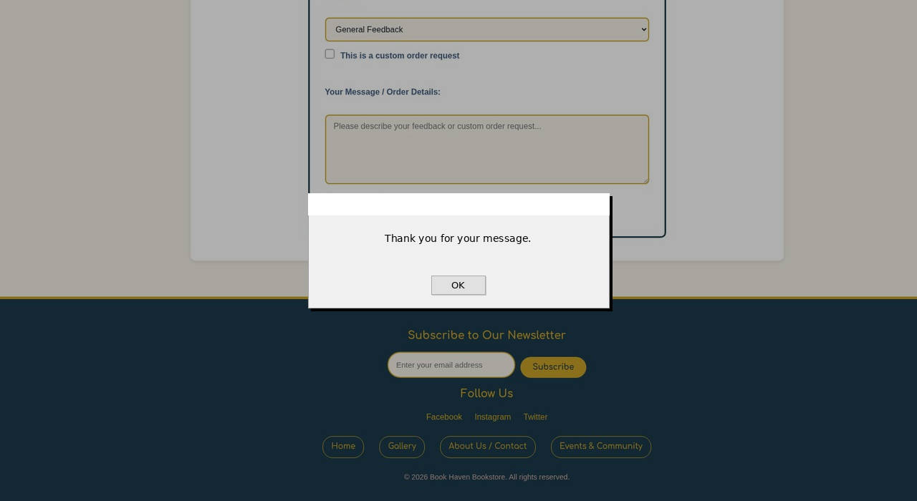

Add to Cart Button Analysis
Hint: Describe how JavaScript is applied to the Add to Cart button. Remember: no shopping cart logic is required.
On the Contact page, I assigned a submit event listener to the contact form using document.getElementById('contact-form'). When the user clicks the Submit button, the event handler calls event.preventDefault() to stop the form from actually submitting to a server, and then displays the alert("Thank you for your message."). This provides user feedback confirming that their message has been received. The required form fields (Full Name and Email Address) are still validated by the browser before the alert displays.
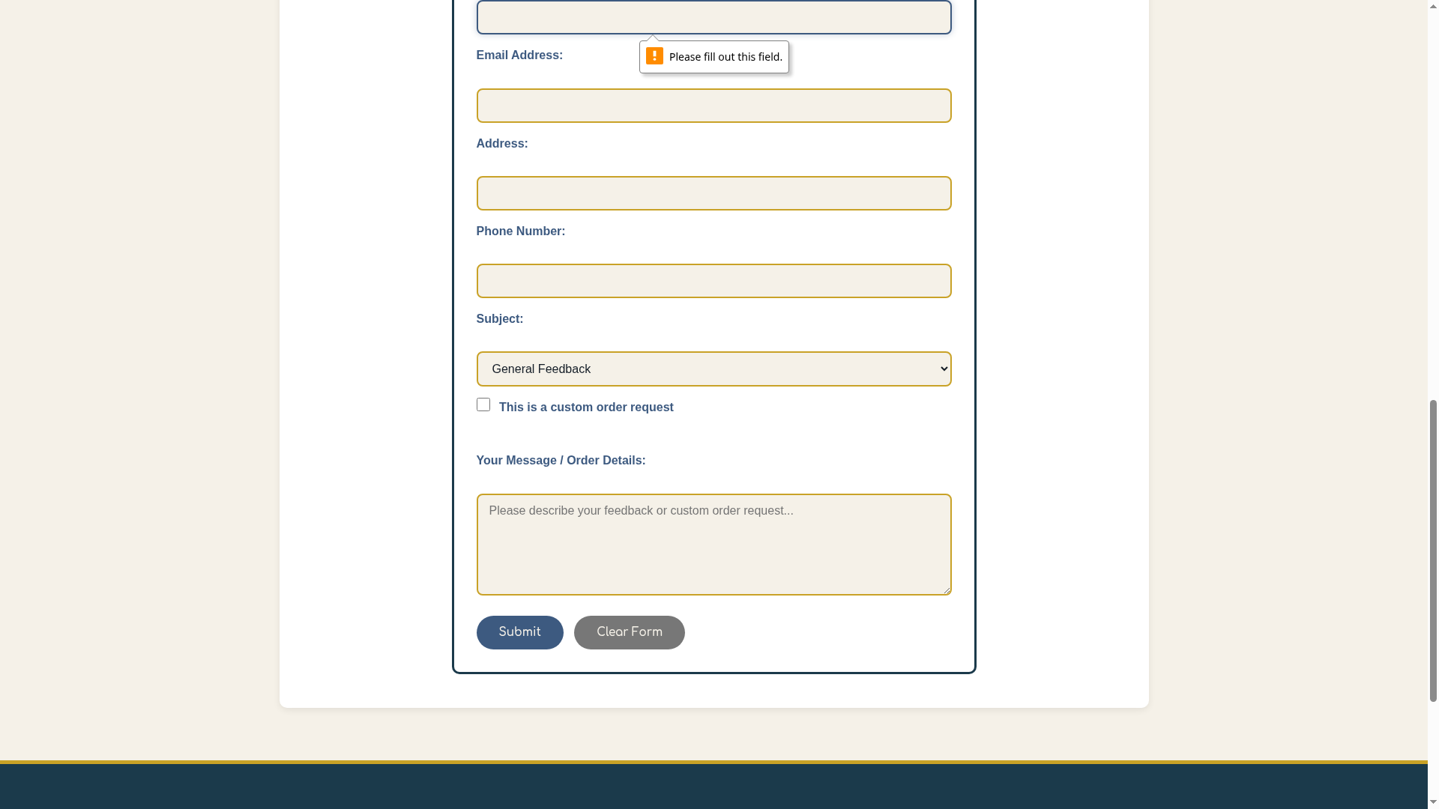
When the contact form is submitted with empty required fields, the browser automatically displays a validation message such as "Please fill out this field." These validation messages are generated by the browser's built-in HTML5 form validation, which checks the required attribute on the input fields. No additional JavaScript is needed to produce these messages. The Full Name and Email Address fields both have the required attribute set, so the browser will prevent form submission and show the tooltip until the user fills in those fields.

Rendered Clear Cart Button Alert Screenshot (Gallery Page)
Hint: Provide a screenshot showing the alert message that appears when clicking the “Clear Cart” button.

Clear Cart Button Analysis
Hint: Describe how the alert message for the Clear Cart button is triggered.

Rendered Process Order Button Alert Screenshot (Gallery Page)
Hint: Provide a screenshot showing the alert message that appears when clicking the “Process Order” button.

Process Order Button Analysis
Hint: Explain how you added the alert to the Process Order button.

Rendered About Us/Contact Page Form Submission Alert Window Screenshot
Hint: Provide a screenshot showing the alert that appears when the Submit button is clicked on the Contact form.

About Us/Contact Page Analysis
Hint: Describe how JavaScript is applied to the Contact page’s Submit button.

Rendered About Us/Contact Page Input Validation Screenshot
Hint: Provide a screenshot showing any validation messages that appear if required fields are empty when the form is submitted. These messages are generated automatically by the browser through built-in HTML form validation. You do not need to write any JavaScript validation for this step.

About Us/Contact Page Input Validation Analysis
Hint: Briefly describe what happens when the form is submitted with missing information. The validation messages you see are created by the browser because the form fields use HTML attributes such as required. No additional JavaScript is needed to produce these message.

Testing and Error Reporting
Hint: Record any errors you encountered while writing or testing your JavaScript code. Describe how you attempted to fix them. If everything worked as expected, note that here.
No errors were encountered while writing or testing the JavaScript code. The event listeners worked as expected on all pages. The alert messages displayed correctly for the Subscribe button, all Add to Cart buttons, the Clear Cart button, the Process Order button, and the Contact form Submit button. The HTML5 form validation also functioned properly without requiring any additional JavaScript.
Since no errors occurred, no fixes were needed. The implementation followed a consistent pattern across all pages: wrapping the event listener code inside a DOMContentLoaded event listener to ensure the DOM was fully loaded before attaching events, using getElementById for unique elements and querySelectorAll for multiple elements (like the Add to Cart buttons), and calling event.preventDefault() on form submissions to prevent page reloads while displaying the alert messages.

